This homework assignment is based on Chapter 5.

**There are 3 print screens, each worth 33.3%**

Project #1 (complete the following using functions).

**#1 print screen the output with code below here.**

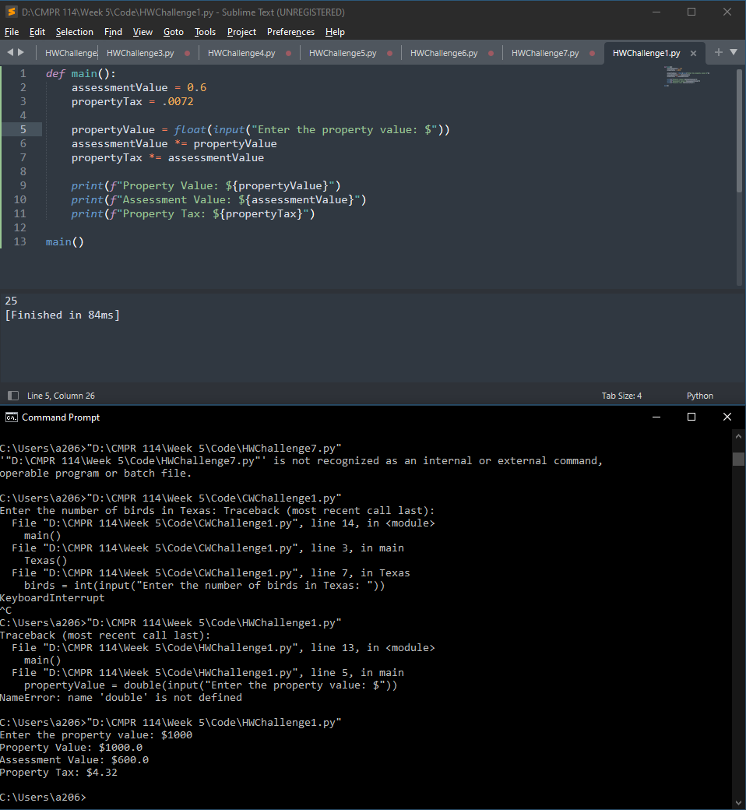

Project #2 (complete the following using functions).

**#2 print screen the output with code below here.**

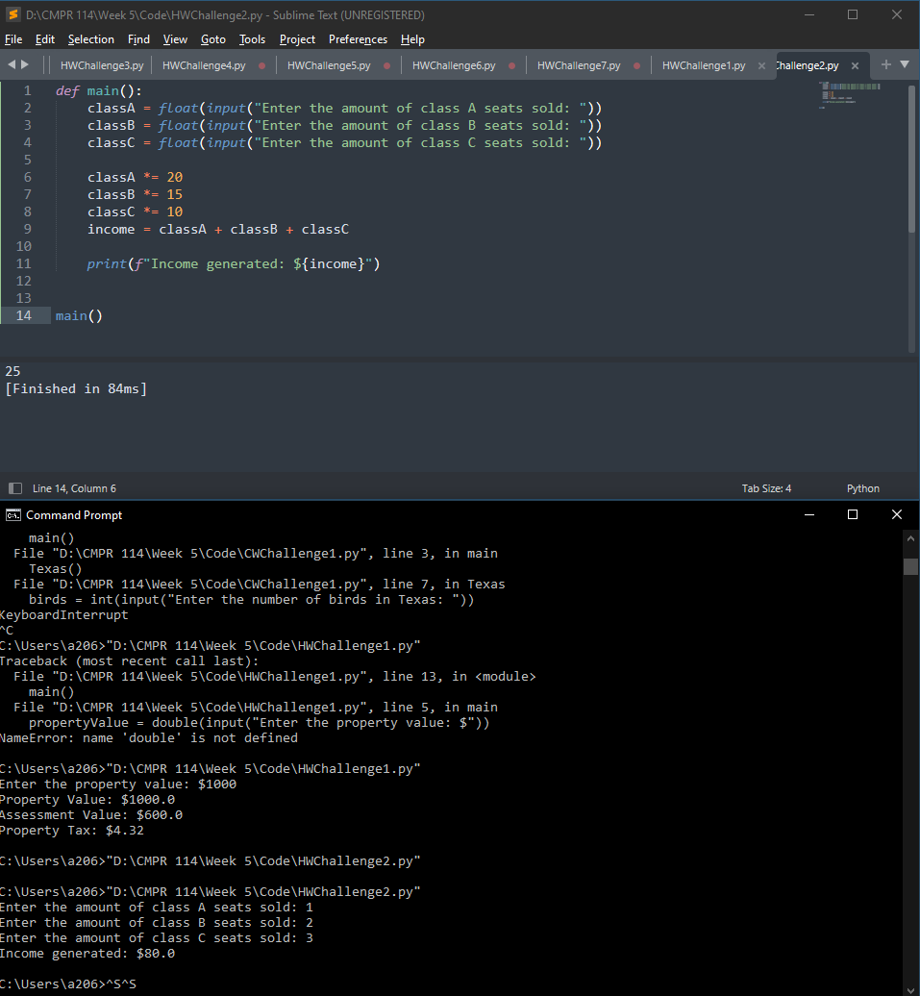

Project #3 (complete the following using functions).

**#3 print screen the output with code below here.**

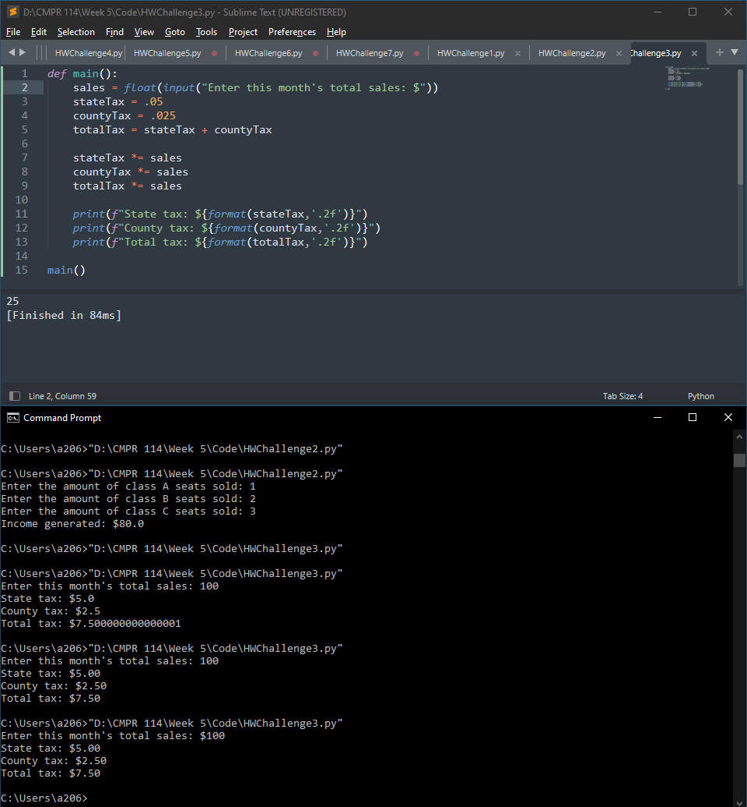

**Submit this document to Module 5 Homework**